Rapid Thermal Sintering of screen-printed LiCoO₂ Films
Walter Sebastian Scheld^{a,b,*}, Sandra Lobeª, Sven Uhlenbruckª, Christian Dellenª, Yoo Jung Sohnª, Linda Charlotte Hoff^{c}, Frank Vondahlenª, Olivier Guillon^{a,d}, Dina Fattakhova-Rohlfing^{a,b}
ª Forschungszentrum Jülich GmbH, Institute of Energy and Climate Research, Materials Synthesis and Processing (IEK-1), 52425 Jülich, Germany and Jülich Aachen Research Alliance: JARA-Energy, 52425 Jülich, Germany
^{b} Faculty of Engineering and Center for Nanointegration Duisburg-Essen (CENIDE), Universität Duisburg-Essen, Lotharstraße 1, 47057 Duisburg, Germany
^{c} Fraunhofer Institute for Laser Technology (ILT), Steinbachstr. 15, 52074 Aachen, Germany
^{d} Institute of Mineral Engineering, RWTH Aachen University, Mauerstr. 5, 52064, Aachen, Germany
* Corresponding author: s.scheld@fz-juelich.de (W. S. Scheld), Institute of Energy and Climate Research – Materials Synthesis and Processing, Forschungszentrum Jülich GmbH, 52425, Jülich, Germany

Key-words: LiCoO₂, Screen Printing, Photonic Sintering, Steel Substrate, Rapid Thermal Processing

Abstract:
A rapid photonic sintering process (rapid thermal processing) was used to obtain compact films of cathode active material of lithium batteries. LiCoO₂ (LCO) thick films were screen-printed on a steel substrate followed by a contactless thermal processing at 1000 °C in only 90 seconds. A homogenous densification of such layers could be verified by scanning electron microscopy, while the structural consistency of the LCO phase in these layers could be detected by X-ray diffraction and Raman spectroscopy. Furthermore, electrochemical activity of the layer was confirmed by electrochemical cell tests with a liquid electrolyte.

- Introduction
The ongoing development of materials and manufacturing processes of thin film electrodes for the use in micro batteries offers the possibility to enable and optimize energy storage systems for special applications [1, 2], such as interactive packaging, medical devices, microelectronics and integrated circuits [3, 4]. Advantageous for these cell types are in addition to their low weight and size, the easy adaption to the device design, higher charge-discharge rates compared to bulk [5], a lower resistance by thinning the layers and deducing from this the possibility of integrating materials with lower ionic conductivity [6].
Thin films can be produced by different processes, which can be classified in two bigger groups. The first group consists of various physical vapor deposition [7, 8] and chemical vapor deposition [9] processes, such as pulsed laser deposition [10] and metal-organic chemical vapor deposition [11]. These processes enable the fabrication of crystalline dense thin layers with a controllable thickness and crystallinity. However, these processes have generally high production costs for thicker films. The second group consists of a two-step process in which at first a layer is created by sol-gel [12] with spin coating [13], or by printing of a ceramic slurry with screen-printing [14-17]. Secondly, the densification of the resulting layer takes place in a separate sintering step. Among these methods, the screen printing process stands out for its easily adjustable and larger layer thickness, simplicity and low cost, which makes it suitable for industrial large scale applications and is already commonly used in the industrial production of solar cells [16, 18, 19].
Even though screen printing enables a fast and economic layer production, the densification is usually linked to a heat treatment with conventional furnaces. The slow heating rates and usually long holding times in the furnaces thus significantly increase the production time. A faster alternative is sintering with light, known as photonic sintering. In this process, the layers are contactless heated by the absorption of light in a quartz-lined furnace with lamps from all sides at high heating rates of up to 100 K s⁻¹. This scalable process is known as rapid thermal processing (RTP). This method is applicable for strongly absorbing materials and is particularly suitable for printed films up to ~100 µm. For such layers, energy transfer is more efficient compared to thicker geometries with hundreds of µm, where large temperature gradients can lead to cracking or spalling of material.
A material suitable for this process is LiCoO₂ (LCO), a frequently used cathode material in thin film applications [10, 20, 21]. It has a high electronic conductivity of 10⁻³ S cm⁻¹ at room temperature [22] and it has a practical specific capacity of ~140 mAh g⁻¹ [23]. Until now, for screen printed LCO layers Al₂O₃ or Si-wafers, coated with Pt and thus served as current collectors, were used as substrate [14-16, 24]. The current collectors used in this way require an additional step to apply Pt and are cost-intensive. A more suitable setup would be printing directly onto a thin electrically conductive and comparatively low-cost substrate, like a high temperature stable steel. Thus, saving a production step by directly bonding the current collector with the cathode, providing additionally mechanical strength and opens the accessibility as bipolar interconnector for battery stacking applications. Another promising process for LCO thin films on steel substrates was realized by spin coating an LCO precursor solution with polyvinylpyrrolidone followed by ultraviolet treatment and subsequent low temperature treatment at 400 °C [25]. However, spin coating tends to produce rather thin layers and it is not certain whether this process is also applicable for thicker layers, like those obtained via screen printing.
In the present study, we investigated the applicability of the RTP system for the densification of LCO thick films. A rapid processing route was developed to produce dense cathode layers on a stainless steel (acting simultaneously as a current collector) via a combination of the economical screen printing process and photonic sintering with RTP.
- Experimental
  - Sample Preparation
Commercial LCO powder (MTI Corporation) was milled in iso-propanol (Alfa Aesar, 99.5%) in a micro-planetary mill (Pulverisette 7, Fritsch). After drying overnight at 50 °C in air the particles were mixed with a solution of an isomeric mixture of terpineol (Sigma-Aldrich, 99.5%) with 6 wt% ethyl-cellulose (Sigma Aldrich, 46 cps, 48% ethoxyl basis) and homogenized in a three roll mill (50l, EXAKT) with a minimum roll distance of 10 µm. The substrates (EN 1.4767 steel, VDM Metals) were cleaned in acetone (Merck, 99.9%), rinsed with iso-propanol and dried immediately. The layers were produced by screen printing (E2, EKRA) with a polyester screen (27-120 x22.5°, KOENEN). The wet layers were dried overnight at 50 °C in air and pre-densified with a warm press (40 EH-Servo, P/O/Weber) at 150 °C with 200 kN for 2 minutes. Afterwards the binder was removed in a heat treatment process in air with a heating rate of 2 K min⁻¹ up to 500 °C without a dwell time, followed by free cooling. The sintering process was carried out in a RTP device (XERION), with a Pt-Rh thermocouple control with contact to a non-coated substrate as reference. The heating rate of the RTP was 600 K min⁻¹ and temperatures up to 1050 °C without any dwell time were investigated. Battery cell tests were carried out in ECC-Combi test equipment (EL-Cell®) with a liquid electrolyte (Sigma Aldrich, 99.9%), consisting of 1M LiPF₆ in ethylene carbonate and dimethyl carbonate (50:50 vol.%), glass fiber separator (EL-Cell®) and lithium metal as anode.

  - Characterization
The particle size of the milled LCO particles were investigated by laser diffraction (LA 950V2, Horiba) with the Mie-theory in ethanol. Crystallographic investigations were carried out with an X-ray diffraction (XRD) device (D4 Endeavor, Bruker) between 10-80° in 2θ with the Bragg-Brentano Geometry and Raman spectroscopy mapping (Invia Qontor, Renishaw) with a 532 nm laser and a 1800 l mm⁻¹ grating were performed with a laser power of about 5 mW and 1 s exposure time. In situ high temperature (HT) XRD measurements were performed (Empyrean, Malvern Panalytical) with a heating rate of 5 K min⁻¹, where the XRD-data were collected between 10-80° in 2θ for every 100 °C step, starting at 600 °C. The total data collection time at each temperature yielded ~ 24 min. The fracture edges for the scanning electron microscopy (SEM) images were made by breaking the specimens after cooling in liquid nitrogen. After sputtering of a thin Pt layer, the samples were analyzed by SEM (EVO-15, Zeiss) with an acceleration voltage of 15 kV. The SEM was equipped with a detector for energy dispersive X-ray spectroscopy (EDS) measurements (Ultim Max 100, Oxford Instruments). The optical absorption was measured in reflection mode with a UV-Vis-NIR spectrometer (1050 Lambda, Perkin Elmer). Cell tests (galvanostatic cycling with potential limitation) were carried out with a battery testing station (VMP-300, Biologic) with an applied current of 0.44 µA cm⁻². The area of the cathode is 2.27 cm² and the mass of the active material is 14 mg.
- Results and discussion
  - Optical properties
Screen printing of a slurry of LCO powder on a stainless steel substrate produces homogeneous, black colored and flat layers. The black color of the layer system is important for the followed densification step with the photonic sintering by RTP. Since the RTP furnace generates a continuous radiation by incandescent filaments at around 3000 K, the intensity of the radiation is very high in the visible and the near infrared range. An optical absorption measurement of a pressed and binder removed LCO layer on steel (Figure 1) reveals a high optical absorption of the system in the visible and near infrared range, consequently resulting in a high energy transfer from the radiation source to the sample. This high energy transfer makes photonic sintering possible, since only in this way rapid heating rates of 600 K per minute can be realized inside the layer with the RTP furnace.
Figure 1: Optical absorption measurement of a pressed and binder-free LCO layer on steel in the visible spectrum and part of the near infrared spectrum.
As can be seen from the optical images (Figure 2), the samples heated to 700, 800 and 900 °C show no observable change of their surface after the RTP treatment, while the samples heated at 1000 and 1050 °C had a circular change in color. The macroscopic surface change of the sample suggests that certain processes such as sintering of the LCO could take place at around 1000 °C. The inhomogeneous surface indicates that the sample had probably a temperature gradient from the middle to the edges. In the further analysis, the inner part of the samples was investigated.
Figure 2: Heat treated samples of LCO printed on EN1.4767 substrate (Ø 17 mm) with their process temperature.
  - Microstructural Investigation
SEM images (Figure 3) confirm the suggestion that no sintering takes place at temperatures below 1000 °C. While no significant sintering is observed for the 900 °C treated sample with only slightly altered shape of the initial particles (Figure 3a and Figure 3b), for the samples treated at 1000 °C (Figure 3c) a pronounced sintered smooth and homogenous surface is observable. The lower limit at which the material starts to sinter in the RTP process must therefore be between 900 and 1000 °C. So far, pure LCO material was sintered as a cast tape at 1270 °C for 10 hours, while hot pressed pellets were sintered at 950 °C for 5 hours with 20 MPa [26, 27]. Using sintering additives such as Li₃BO₃, the temperature could be reduced to 700 °C and 1 hour dwell time[17]. In contrast, the RTP sintering of LCO films allows an immense reduction of the processing time at the elevated temperatures, as the entire heat treatment process with heating and dwell time takes only 90 seconds at a maximum temperature of about 1000 °C.
The initial particles have grown into two-dimensional coherent connected structures with sizes ranging from 8 – 15 µm. Considering the starting particle size of D₁₀ 1.7 µm, D₅₀ 5.9 µm, D₉₀ 11.9 µm, the particle size difference illustrates the grain growth and the associated sintering step that has taken place. The back scattered electron image (Figure 3d) demonstrates that some small cracks have formed. Since the coefficient of thermal expansion of the EN 1.4767 (1.22 - 1.48 ∙ 10⁻⁵ K⁻¹ at 100 °C – 900 °C according to the manufacturer), LCO (1.3 ∙ 10⁻⁵ K⁻¹ at 50 °C - 400 °C) [28] and Al₂O₃ thin films (1.3 ∙ 10⁻⁵ K⁻¹ at 300 °C and 3.9 ∙ 10⁻⁵ K⁻¹ at 1073 °C) [29] are close to each other, the reason for the cracks is probably sintering mismatch induced by the densification of LCO on the stiff substrate which very likely does not shrink during the heat treatment. In addition, the image shows some planar LCO structures vertical to the sintered layer. It is possible that this orientation has an influence on the performance of the electrode, since the ionic conductivity in LCO is depending on the spatial orientation [30]. In contrast, the back scattered electron image of the 900 °C treated sample (Figure 3b) does not show any of these structures. For this reason, their origin is probably attributable to the sintering process at 1000 °C.
At the bottom of the fracture cross-section of the 1000 °C treated specimen (Figure 3e) with an average LCO layer thickness of ~15 µm the steel substrate is visible and the sintered LCO layer is on top. Based on this image, the LCO layer is sintered through its entire thickness. A gap between the layer and the steel substrate has formed, as the layer has detached from the steel during the fracture preparation. Evidence of the bond between LCO and the steel is given by a polished cross-section image (Figure 3f) with an adherent layer on the substrate.
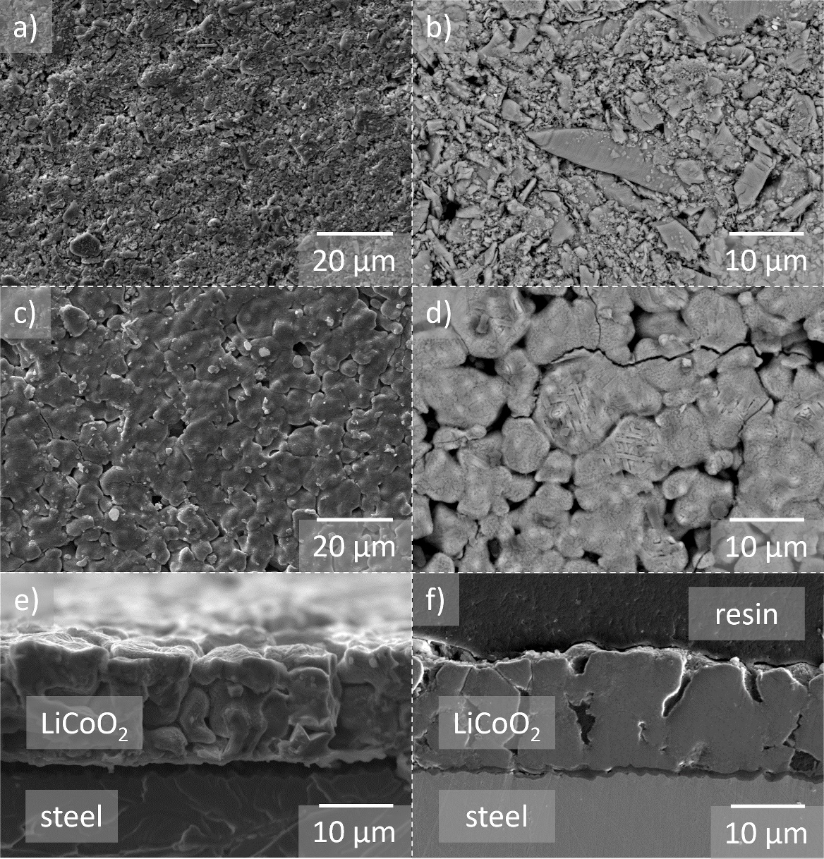
Figure 3: SEM images of heat treated LCO samples: a) secondary electron image of the 900 °C sample, b) back scattered electron image of the 900 °C treated sample c) secondary electron image of the 1000 °C sample, d) back scattered electron image of the 1000 °C treated sample, e) secondary electron image of a fractured cross-section from the 1000 °C treated sample, f) secondary electron image of a polished cross-section of the LCO sample treated at 1000 °C.
The EN 1.4767 steel substrate consists mainly of Fe, Cr and Al. At high temperatures, an Al₂O₃ layer in general forms on the steel, which serves as a passivation layer[31]. In the polished cross-section, this passivation oxide is observable as a continuous layer below the LCO film and between the cathode and the substrate (Figure 3f). The cathode film has sintered with the passivation layer and these have detached from the steel together.

EDS measurements of the electrode cross-section (Figure 4) show clearly defined areas of each layer (Co: cathode, Al: Al₂O₃ passivation layer, Fe: steel substrate). It cannot be excluded that some ion interdiffusion takes place at the interface of the LCO and the Al₂O₃ passivation layer with formation of, e.g. LiAlO₂ due to lithium diffusion into the Al₂O₃ phase [32] or LiAl_{y}Co_{1-y}O₂ [33] due to Al diffusion into the LCO structure. However, EDS measurements do not provide any unequivocal evidence of such reactions. Low intensity Al signals can be found in LCO above the passivation layer, but only in the areas where the morphology of the cathode not planar. Due to this morphology dependency the signals are not necessarily an indication for the mentioned LiAl_{y}Co_{1-y}O₂ phase but may possibly be an effect of a height difference in the measurement.
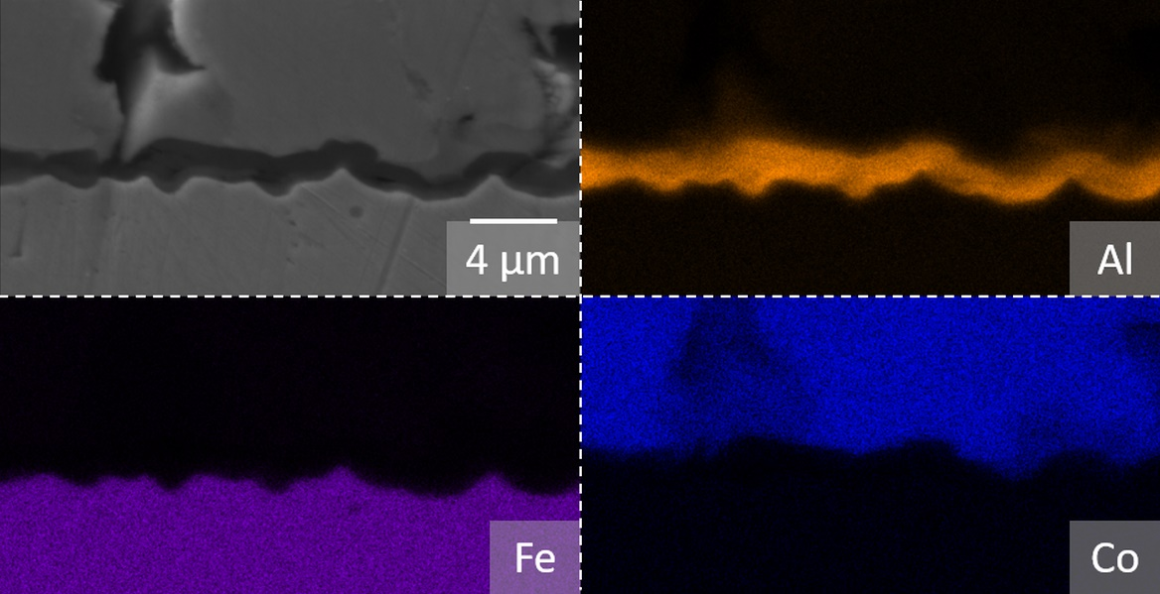
Figure 4: EDS Mapping of the Al₂O₃ interface between the steel substrate at the bottom and the cathode on top with a secondary electron image of the measured area with the element mappings of Al, Fe and Co.
With an even higher sintering temperature of 1050 °C, the surface has less pores, but also the number and size of cracks are increasing (Figure 5a). It is possible that the origin of the cracks is given by areas with greater distance to the surrounding material, and thus at higher temperatures the sintering of the material in this area is prevented and the cracks become wider due to the sintering of the material on both sides of the initial spacing. Another origin could be a temperature induced bending of the substrate. The planar, vertical LCO structures are also observable at 1050 °C (Figure 5b).
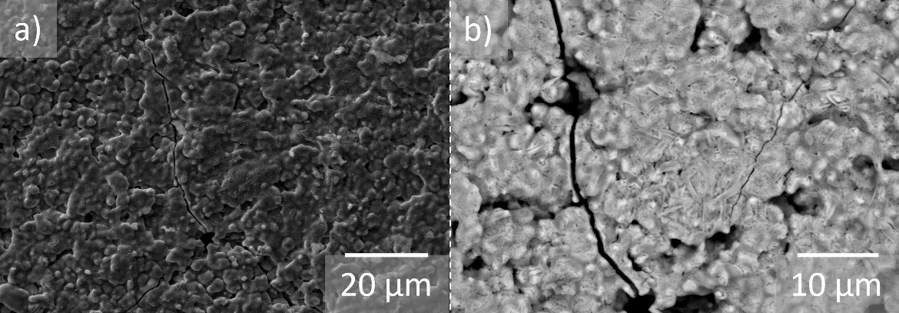
Figure 5: SEM images of heat treated LCO samples at 1050 °C: a) secondary electron image of the sample, b) back scattered electron image of the sample.
  - Phase characterization
The chemical stability of the LCO layers against the EN 1.4767 steel was investigated by in situ HT-XRD (Figure 6a). It must be mentioned that the Bragg reflections have a shift to lower angles due to the thermal expansion of the sample. The shown LCO reference (ICDD 00-016-0427) refers to room temperature. The LCO phase is observable up to 1000 °C. However, a decomposition of the LCO phase starts at 1000 °C, and an additional CoO phase (ICDD 01-070-2855) is detected. At 1100 °C a full decomposition takes place and the reflections of LCO are no longer present, and only the CoO phase can be observed. It can be however concluded, that even if a small amount of side phases is formed, the selected steel provides a suitable chemical stability to the cathode material in the required sintering temperature range up to 1000 °C.
The ex-situ XRD analysis of the RTP treated LCO samples (Figure 6b) reveals the existence of a phase pure rhombohedral structure until 900 °C. At higher temperatures, besides the main LCO phase, CoO is observable as secondary phase, similar to the HT-XRD measurements. Additionally, the LCO reflections are becoming broader with higher temperature, possibly due to a loss of crystallinity. Due to the layer thickness the 900 °C and 1000 °C treated samples show reflexes of the steel substrate.
The secondary phases with the steel substrate and its passivation layer discussed above could not be determined due to a large thickness of the cathode layer preventing detection of any phases beneath the LCO layer.
Figure 6: a) (left): In situ HT-XRD measurements of LCO on EN 1.4767 steel. The heating rate was 5 K min⁻¹ and each measurement took 24 minutes. The reflections show a shift to lower angles due to the increased temperature. b) (right): XRD measurements of the differently treated LCO samples. The LCO reference (ICDD 00-016-0427) is shown by blue lines and the CoO-phase (ICDD 01-070-2855) is indicated with °, reflexes of the 1.4767 steel substrate are indicated with *.
In addition to the XRD data, Raman spectra of the LCO samples treated at different temperatures were measured to assess the phase composition (Figure 7). The LCO material has two vibrational modes (A_{1g} and E_{g}), which are observable by Raman spectroscopy and belong to the rhombohedral lattice with the space group $\text{R}\overline{\text{3}}\text{m}$ [34-36]. These two signals are observable at all measured spectra (Figure 7) at 488 cm⁻¹ (E_{g}), 597 cm⁻¹ (A_{1g}) and at 1170 cm⁻¹ where a broad A_{1g} overtone is existing and thus show evidence of the presence of the LCO phase in the RTP treated samples [36, 37]. With higher temperatures, the wavenumber shows a small shift to lower wavenumbers. The 1000 °C sample has the A_{1g} at 595 cm⁻¹ and at the 1050 °C sample the A_{1g} is at 593 cm⁻¹. The shift indicates a loss of Li atoms within the lattice, which is more pronounced at higher temperatures [38].
Besides LCO, signals of Co₃O₄ are observable at 534 cm⁻¹ and 680 cm⁻¹ as side phase, signed with (°) [39]. The line broadening of the LCO signals indicates an increased disorder in the crystal structure. Including the stronger signal of Co₃O₄ a loss of lithium atoms is the most probable. However, since no other Li residues like Li₂O and just small signals of Li₂CO₃ at 1090 cm⁻¹ are detected, there could also be a random distribution of Li atoms between the LCO layers in the lithium planes of the crystal [40]. This random distribution, which is already described in literature[34], is possibly leading to the observed broadening. Nevertheless, the Raman measurements, like the XRD measurements, show the main phase is LCO even after the high temperature treatment.
Figure 7: Stack plot of Raman spectroscopy measurements from the differently treated LCO samples with signed secondary phases and the wavenumber of the A_{1g} LCO Signal.
  - Electrochemical investigation
Although the results of the SEM, XRD and Raman measurements demonstrate a densification of the LCO layers at 1000°C without significant phase changes, the electrochemical performance of such layers still needs further optimization. The first three galvanostatic cycles (Figure 8a) with liquid electrolyte demonstrate that the screen printed LCO layers are electrochemically active after the RTP sintering process at 1000 °C, as the characteristic plateaus of LCO charge and discharge are observed at a potential around 3.9 V [23]. However, the capacity utilization in a thick layer is relatively low, as only around 52 mAh g⁻¹ has been reached in the first charging cycle, with a fast capacity degradation in the subsequent cycles. Due to the low ionic conductivity of LCO, the thickness of the cathode layer is probably hindering efficient lithiation and delithiation inside the cathode. Compared to conventional LCO cathodes, the relative layer thickness of the RTP sintered layer is larger, considering the aspects that the layer is sintered and thus has a higher density than the binder-bonded cathodes, and additionally it is a pure LCO layer without conductive additives such as carbon black. Also, some cobalt oxides side phases were found by Raman spectroscopy and XRD measurements. These oxides are a direct result of the lithium loss in the LCO and therefore also generate a reduction in capacity.
In comparison, cell tests with cathodes produced at 900 °C and 1050 °C show (Figure 8b) a significantly lower capacity utilization in the lower µAh g⁻¹ region for the 1050 °C treated sample and even lower capacity utilization for the 900 °C treated sample. The low capacity values for the 900 °C treated sample are not surprising, since a large part of the cathode is inaccessible due to insufficient sintering and a poor contact with the current collector. For the sample produced at 1050 °C, the loss of connectivity within the electrode layer and the respective reduction in capacity utilization can be attributed to the formation of cracks discussed above. Furthermore, for this sample formation of the higher amount of cobalt oxides is detected by the Raman spectroscopy and XRD measurements, which can also reduce the specific capacity of the cathode. Cell tests demonstrate a very strong effect of the temperature on the performance of RTP sintered cathodes. The temperature should be therefore selected very precisely within a narrow range between 900 °C to 1050 °C to achieve satisfactory electrochemical performance.
The time and energy savings mentioned above compared to conventional production routes offer great potential for the commercial application of battery technology using screen printing and RTP. However, the capacity of the cathodes must be increased, and a suitable method of electrolyte deposition and sintering must be developed for a functional half-cell production. The use of a composite instead of a pure cathode layer is also conceivable to increase the ionic conductivity within the cathode layer. If these obstacles are overcome, industrial upscaling of the manufacturing processes would be easy, since the layer thickness can be adjusted and the printed area can be increased and handled in RTP, allowing significantly higher throughputs of material to be processed.
Figure 8: Charge and Discharge Capacity vs. Cell Voltage of a) a LCO layer sintered at 1000°C and b) LCO layers sintered at 900 °C (blue) and 1050 °C (red), cycling with 1M LiPF₆ in EC/DMC as electrolyte and Li metal as anode between 3.0 V and 4.2 V.
- Conclusion:
LCO films were fabricated by screen printing on an EN 1.4767 steel substrate. The photonic and contactless sintering of the LCO films was carried out by RTP at different temperatures by using the high optical absorption of LCO. The steel substrate acted as current collector and enabled the mechanical stability of the system. SEM images revealed that sintering at 1000 °C leads to dense ~15 µm thick, smooth layers in a sintering time of only 90 s. XRD measurements and Raman spectroscopy indicated LCO as the main phase, while CoO and Co₃O₄ have formed as minor secondary phases for temperatures higher than 1000 °C. Lower temperatures showed insufficient densification, while higher temperatures lead to an increased amount of cracks in the layer and an increased amount of side phases. Electrochemical activity could be proven by cell tests with liquid electrolyte.

Declaration of Competing Interest
The authors declare no conflict of interest.

Acknowledgment
This work was funded by the German Federal Ministry for Economic Affairs and Energy (BMWI) within of the OptiKeraLyt project(FKZ: 03ETE016F) and is gratefully acknowledged here. The authors would like to thank Andrea Hilgers for the help with PSD analysis and Mark Kappertz for the help with the SEM sample preparation. The authors would like to thank VDM Metals for providing the EN 1.4767 steel.

Received: ((will be filled in by the editorial staff))
Revised: ((will be filled in by the editorial staff))
Published online: ((will be filled in by the editorial staff))

References
[1] L. Hu, H. Wu, F.L. Mantia, Y. Yang, Y. Cui, Thin, Flexible Secondary Li-Ion Paper Batteries, ACS Nano, 4 (2010) 5843-5848.
[2] N.J. Dudney, B.J. Neudecker, Solid state thin-film lithium battery systems, Current Opinion in Solid State and Materials Science, 4 (1999) 479-482.
[3] Y. Wang, B. Liu, Q. Li, S. Cartmell, S. Ferrara, Z.D. Deng, J. Xiao, Lithium and lithium ion batteries for applications in microelectronic devices: A review, Journal of Power Sources, 286 (2015) 330-345.
[4] J.F.M. Oudenhoven, L. Baggetto, P.H.L. Notten, All-Solid-State Lithium-Ion Microbatteries: A Review of Various Three-Dimensional Concepts, Advanced Energy Materials, 1 (2011) 10-33.
[5] J. Sastre, X. Chen, A. Aribia, A.N. Tiwari, Y.E. Romanyuk, Fast Charge Transfer across the Li₇La₃Zr₂O₁₂ Solid Electrolyte/LiCoO₂ Cathode Interface Enabled by an Interphase-Engineered All-Thin-Film Architecture, ACS Appl Mater Interfaces, 12 (2020) 36196-36207.
[6] C. Julien, Z. Stoynov, Materials for Lithium-Ion Batteries, 1 ed., Springer Netherlands, 1999.
[7] S. Lobe, A. Bauer, S. Uhlenbruck, D. Fattakhova‐Rohlfing, Physical Vapor Deposition in Solid‐State Battery Development: From Materials to Devices, Advanced Science, (2021).
[8] S. Uhlenbruck, J. Dornseiffer, S. Lobe, C. Dellen, C.-L. Tsai, B. Gotzen, D. Sebold, M. Finsterbusch, O. Guillon, Cathode-electrolyte material interactions during manufacturing of inorganic solid-state lithium batteries, Journal of Electroceramics, 38 (2016) 197-206.
[9] J.F.M. Oudenhoven, T. van Dongen, R.A.H. Niessen, M.H.J.M. de Croon, P.H.L. Notten, Low-Pressure Chemical Vapor Deposition of LiCoO₂ Thin Films: A Systematic Investigation of the Deposition Parameters, Journal of The Electrochemical Society, 156 (2009).
[10] Y. Matsuda, N. Kuwata, J. Kawamura, Thin-film lithium batteries with 0.3–30 μm thick LiCoO₂ films fabricated by high-rate pulsed laser deposition, Solid State Ionics, 320 (2018) 38-44.
[11] J. Xie, J.F.M. Oudenhoven, P.-P.R.M.L. Harks, D. Li, P.H.L. Notten, Chemical Vapor Deposition of Lithium Phosphate Thin-Films for 3D All-Solid-State Li-Ion Batteries, Journal of The Electrochemical Society, 162 (2014) A249-A254.
[12] P.N. Hishimone, K. Watarai, H. Nagai, M. Sato, Thin Film Fabrication and Characterization of Layered Rock Salt LiCoO₂ on Quartz Glass Spray-Coated with an Aqueous Ammonia Solution Involving Metal Acetates, Coatings, 9 (2019).
[13] J.P. Maranchi, A.F. Hepp, P.N. Kumta, LiCoO₂ and SnO₂ thin film electrodes for lithium-ion battery applications, Materials Science and Engineering: B, 116 (2005) 327-340.
[14] M.S. Park, S.H. Hyun, S.C. Nam, Characterization of a LiCoO₂ thick film by screen-printing for a lithium ion micro-battery, Journal of Power Sources, 159 (2006) 1416-1421.
[15] M.S. Park, S.H. Hyun, S.C. Nam, Preparation and characteristics of LiCoO₂ paste electrodes for lithium ion micro-batteries, Journal of Electroceramics, 17 (2006) 651-655.
[16] M.-S. Park, S.-H. Hyun, S.-C. Nam, Mechanical and electrical properties of a LiCoO₂ cathode prepared by screen-printing for a lithium-ion micro-battery, Electrochimica Acta, 52 (2007) 7895-7902.
[17] S. Ohta, S. Komagata, J. Seki, T. Saeki, S. Morishita, T. Asaoka, All-solid-state lithium ion battery using garnet-type oxide and Li₃BO₃ solid electrolytes fabricated by screen-printing, Journal of Power Sources, 238 (2013) 53-56.
[18] V. Shanmugam, J. Cunnusamy, A. Khanna, M.B. Boreland, T. Mueller, Optimisation of Screen-Printed Metallisation for Industrial High-Efficiency Silicon Wafer Solar Cells, Energy Procedia, 33 (2013) 64-69.
[19] J. Schnell, F. Tietz, C. Singer, A. Hofer, N. Billot, G. Reinhart, Prospects of production technologies and manufacturing costs of oxide-based all-solid-state lithium batteries, Energy & Environmental Science, 12 (2019) 1818-1833.
[20] K. Mizushima, P.C. Jones, P.J. Wiseman, J.B. Goodenough, LixCoO₂ (0<x<-1): A new cathode material for batteries of high energy density, Materials Research Bulletin, 15 (1980) 783-789.
[21] M. Takahashi, M. Hayashi, T. Shodai, Characterization of all-solid-state secondary batteries with LiCoO₂ thin films prepared by ECR sputtering as positive electrodes, Journal of Power Sources, 189 (2009) 191-196.
[22] H. Tukamoto, A.R. West, Electronic Conductivity of LiCoO₂ and Its Enhancement by Magnesium Doping, Journal of the Electrochemical Society, 144 (1997) 3164-3168.
[23] D. Deng, Li‐ion batteries: basics, progress, and challenges, Energy Science & Engineering, 3 (2015) 385-418.
[24] S.-T. Lee, S.-W. Jeon, B.-J. Yoo, S.-D. Choi, H.-J. Kim, S.-M. Lee, Electrochemical properties of LiCoO₂ thick-film cathodes prepared by screen-printing technique, Journal of Power Sources, 155 (2006) 375-380.
[25] B. Yun, T.T. Bui, P. Lee, H. Jeong, S.B. Shin, S.K. Park, S.Y. Kim, M.-G. Kim, Photo-assisted low temperature crystallization of solution-derived LiCoO₂ thin film, Materials Research Bulletin, 138 (2021).
[26] H. Zhang, P.J. Baker, P.S. Grant, Fabrication and Electrical Properties of Bulk Textured LiCoO₂, Journal of the American Ceramic Society, 93 (2010).
[27] H. Yamada, T.S. Suzuki, T. Uchikoshi, M. Hozumi, T. Saito, Y. Sakka, Ideal design of textured LiCoO₂ sintered electrode for Li-ion secondary battery, APL Materials, 1 (2013).
[28] E.J. Cheng, N.J. Taylor, J. Wolfenstine, J. Sakamoto, Elastic properties of lithium cobalt oxide (LiCoO2), Journal of Asian Ceramic Societies, 5 (2018) 113-117.
[29] G. Balakrishnan, R. Thirumurugesan, E. Mohandas, D. Sastikumar, P. Kuppusami, J.I. Songl, Phase transition and thermal expansion studies of alumina thin films prepared by reactive pulsed laser deposition, J Nanosci Nanotechnol, 14 (2014) 7728-7733.
[30] Y. Takahashi, Y. Gotoh, J. Akimoto, S. Mizuta, K. Tokiwa, T. Watanabe, Anisotropic Electrical Conductivity in LiCoO₂ Single Crystal, Journal of Solid State Chemistry, 164 (2002) 1-4.
[31] M. Stanislowski, E. Wessel, T. Markus, L. Singheiser, W. Quadakkers, Chromium vaporization from alumina-forming and aluminized alloys, Solid State Ionics, 179 (2008) 2406-2415.
[32] S. Lobe, C. Dellen, M. Finsterbusch, H.G. Gehrke, D. Sebold, C.L. Tsai, S. Uhlenbruck, O. Guillon, Radio frequency magnetron sputtering of Li₇La₃Zr₂O₁₂ thin films for solid-state batteries, Journal of Power Sources, 307 (2016) 684-689.
[33] Y.-I. Jang, B. Huang, D.S. H. Wang, Y.C. G. Ceder, H. Liu, H. Tamurab, LiAl_{y}Co_{1-y}O₂ (R3–m) Intercalation Cathode for Rechargeable Lithium Batteries, Journal of The Electrochemical Society, 146 (1999) 862-868.
[34] M. Inaba, Y. Iriyama, Z. Ogumi, Y. Todzuka, A. Tasaka, Raman study of layered rock-salt LiCoO₂ and its electrochemical lithium deintercalation, Journal of Raman Spectroscopy, 28 (1997) 613-617.
[35] C. Julien, Local cationic environment in lithium nickel–cobalt oxides used as cathode materials for lithium batteries, Solid State Ionics, 136-137 (2000) 887-896.
[36] T. Gross, C. Hess, Raman diagnostics of LiCoO₂ electrodes for lithium-ion batteries, Journal of Power Sources, 256 (2014) 220-225.
[37] K. Kushida, K. Kuriyama, Optical absorption related to Co-3d bands in sol-gel grown LiCoO₂ films, Solid State Communications, 118 (2001) 615-618.
[38] T. Nishi, H. Nakai, A. Kita, Visualization of the State-of-Charge Distribution in a LiCoO₂Cathode by In Situ Raman Imaging, Journal of The Electrochemical Society, 160 (2013) A1785-A1788.
[39] V.G. Hadjiev, M.N. Iliev, I.V. Vergilov, The Raman spectra of Co₃O₄, Solid State Physics, 21 (1988) L199-L201.
[40] F.S. Gittleson, K.P.C. Yao, D.G. Kwabi, S.Y. Sayed, W.-H. Ryu, Y. Shao-Horn, A.D. Taylor, Raman Spectroscopy in Lithium-Oxygen Battery Systems, ChemElectroChem, 2 (2015) 1446-1457.

List of Figure
Figure 1: Optical absorption measurement of a pressed and binder-free LCO layer on steel in the visible spectrum and part of the near infrared spectrum. 6
Figure 2: Heat treated samples of LCO printed on EN1.4767 substrate (Ø 17 mm) with their process temperature. 7
Figure 3: SEM images of heat treated LCO samples: a) secondary electron image of the 900 °C sample, b) back scattered electron image of the 900 °C treated sample c) secondary electron image of the 1000 °C sample, d) back scattered electron image of the 1000 °C treated sample, e) secondary electron image of a fractured cross-section from the 1000 °C treated sample, f) secondary electron image of a polished cross-section of the LCO sample treated at 1000 °C. 9
Figure 4: EDS Mapping of the Al₂O₃ interface between the steel substrate at the bottom and the cathode on top with a secondary electron image of the measured area with the element mappings of Al, Fe and Co. 10
Figure 5: SEM images of heat treated LCO samples at 1050 °C: a) secondary electron image of the sample, b) back scattered electron image of the sample. 11
Figure 6: a) (left): In situ HT-XRD measurements of LCO on EN 1.4767 steel. The heating rate was 5 K min⁻¹ and each measurement took 24 minutes. The reflections show a shift to lower angles due to the increased temperature. b) (right): XRD measurements of the differently treated LCO samples. The LCO reference (ICDD 00-016-0427) is shown by blue lines and the CoO-phase (ICDD 01-070-2855) is indicated with °, reflexes of the 1.4767 steel substrate are indicated with *. 12
Figure 7: Stack plot of Raman spectroscopy measurements from the differently treated LCO samples with signed secondary phases and the wavenumber of the A_{1g} LCO Signal. 13
Figure 8: Charge and Discharge Capacity vs. Cell Voltage of a) a LCO layer sintered at 1000°C and b) LCO layers sintered at 900 °C (blue) and 1050 °C (red), cycling with 1M LiPF₆ in EC/DMC as electrolyte and Li metal as anode between 3.0 V and 4.2 V. 15

